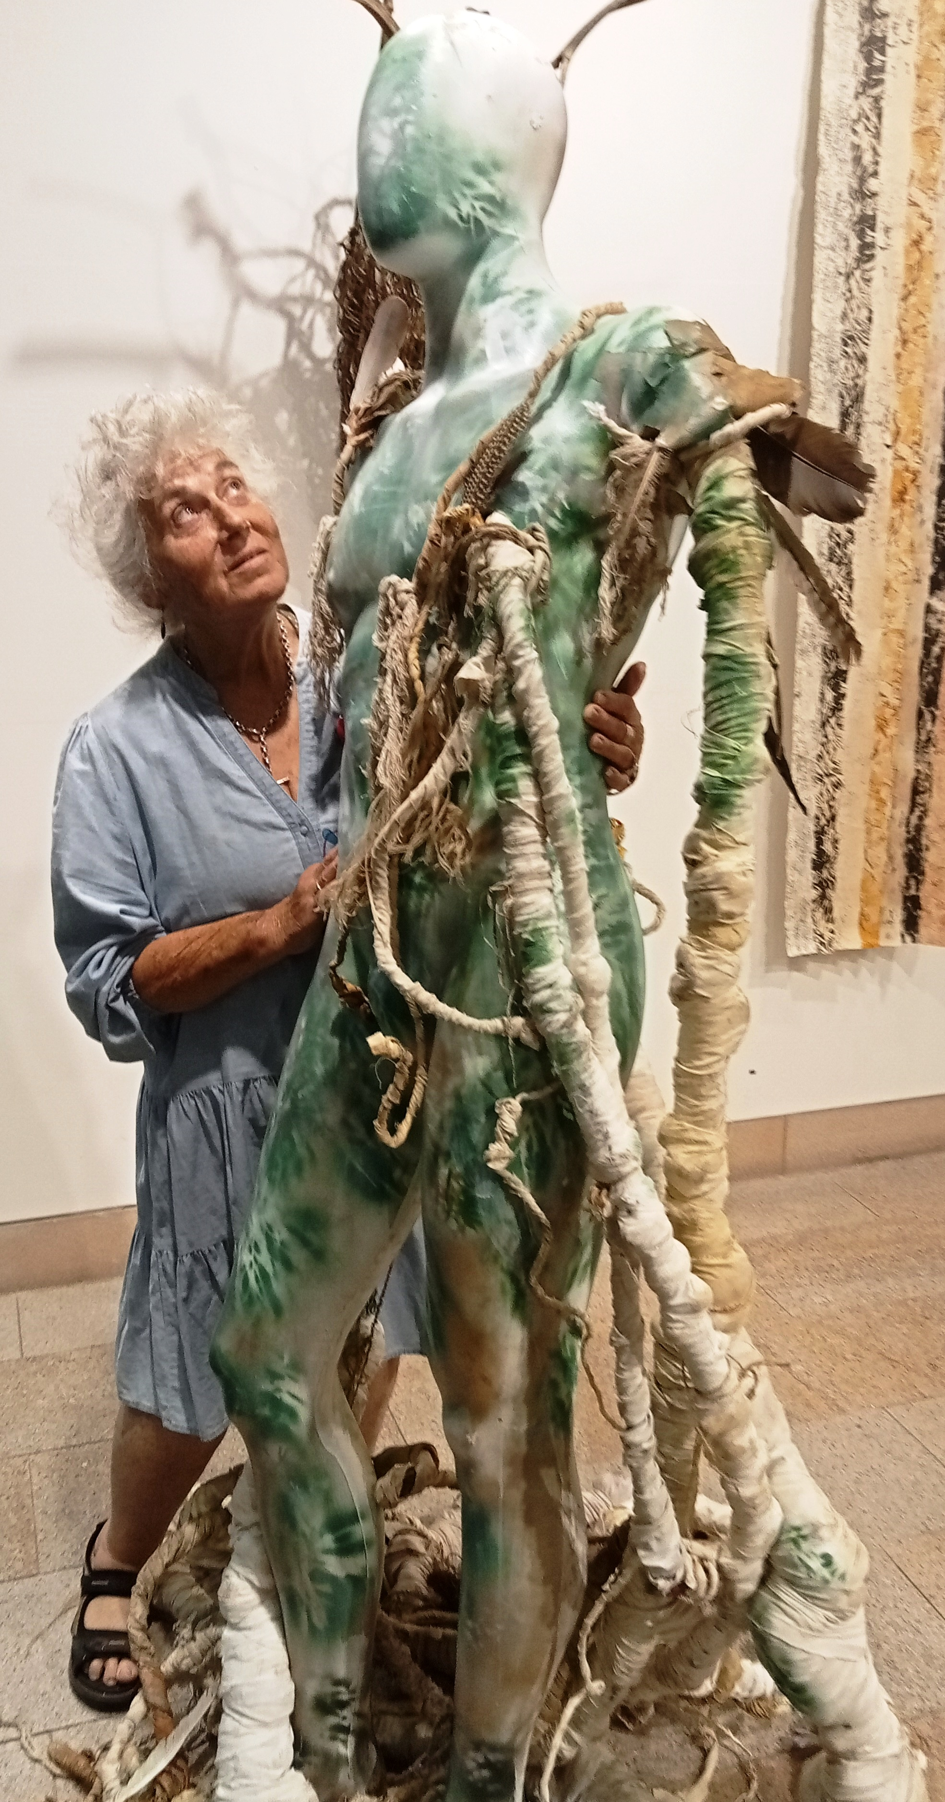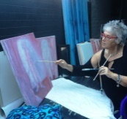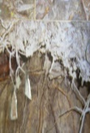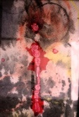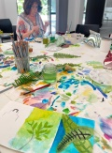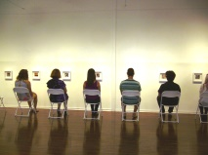
Elizabeth-Anne Gervay ~ artist/educator/environmentalist
MA Art, BA Fine Arts (honours),Dip Ed.,Graduate Sp. Ed.,Graduate Diploma,Facilitating Learning, & Remedial Ed.

Founding member of the environmentalist artist collective The Tree Veneration Society –www.treevenerationsociety.com

PO Box 423 Paddington 2021 e eagervay@gmail.com m 0411141931 www.artsonthemove.com.au

ACHIEVEMENTS
Established & Co-ordinated Creative Arts Centre, Australia Street Public School, Newtown.
Collaborated to establish Reverse Garbage – Addison Road Community Center, Newtown.
Established and conducted a community art workshop for North Sydney Council – The Kirribilli Neighbourhood Center
Established and curated art exhibitions within City of Sydney, North Sydney and Woollahra municipalities (90 plus artists)
Facilitate art workshops for Waverly Council, North Sydney Council, Goulburn Council, Upper Lachlan Council, City of Sydney and Western Sydney
Facilitated workshops for The Tree Veneration Society
Facilitated workshops for Bungonia Historic Society

2012 -2026 Exhibitions: UNSW A&D,
WWAS Waverley
Beams Festival – Chippendale
Art in The Park – Rosebay
Norman Lindsay Gallery
Sydney University
See-Street Gallery Meadowbank
P- Beat Pearl Beach Arboretum, Pearl Beach
107 Redfern
Chatswood Art Space
Grace Cossington-Smith Gallery Hornsby
Chrissie Cottie Gallery, Camperdown
Sheffer Gallery, Darlington
Woolllahra Redleaf Gallery, Woollahra
Marulan Kite Festival, Marulan
Waverley Library
2012 to 2026 - WORKSHOPS
North Sydney: Kirribilli Neighbourhood Center, Greenway Housing, Council Mental Health Week, National Tree Day, Coal Loader, Rudloph Steiner School.
Waverley Council: National Tree Day , Summerama , Flash Sketch classes (Waver;ey Library)
City of Sydney: Science in the Park (Centennial Park) Green Square , West Connect Housing
Woollahra Council: 2023 Arboreal Narratives
Campbelltown Council: National Tree Day (Mt Annan), Campbelltwon Textile Artists
Western Sydney: Resettlement Centre, Auburn.
Goulburn Mulwaree Council Bungonia Community workshops
Wingecarribee Council -Tallong Community workshops

PERFORMANCE
2021-2025 City of Sydney: Sydney Festival 2021 – Paddington Reservoir
“Requiem of Trees” with Dirty Witches and Woollahra Council: 2023 Arboretum Narratives

Company and Institutional Collections include
Wakayama University - Japan, Meridian Information Service, Sydney, APS Constructions, Sydney, Austins Pty Ltd, Sydney, G&R Property, Sydney,
Co-Gain Management Company, Sydney, Outotec Pty Ltd, Larox Pty Ltd, Simonworld Pty Ltd

Works are also held in private international and national collections

